**Приложение 1**

**Математика**

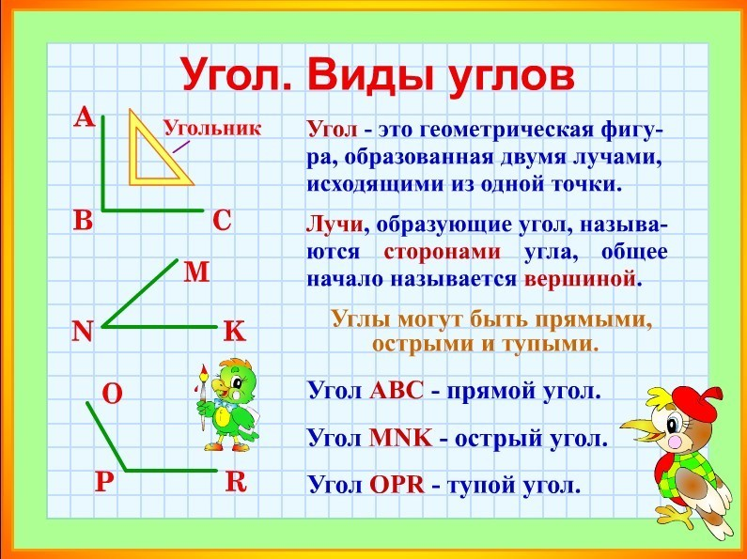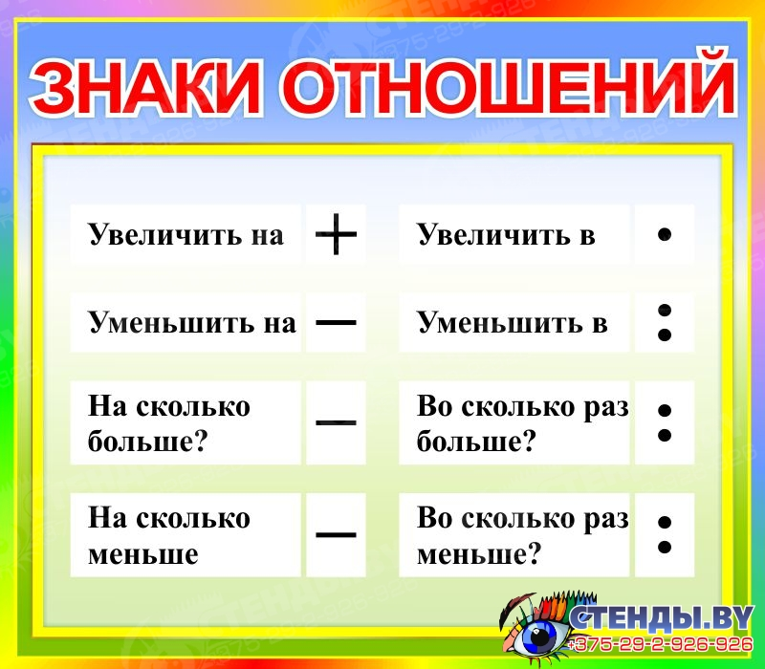

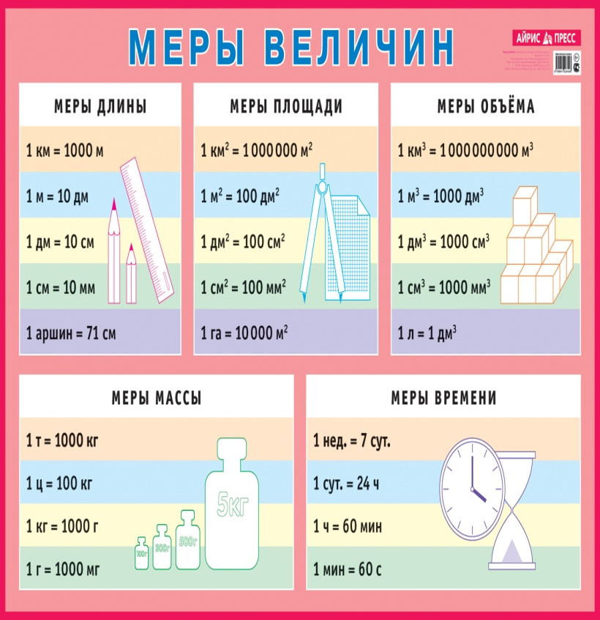[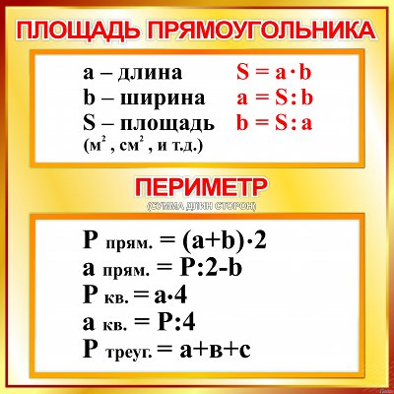](https://go.mail.ru/search_images?q=%D0%BF%D0%BB%D0%BE%D1%89%D0%B0%D0%B4%D1%8C%20%D0%BF%D1%80%D1%8F%D0%BC%D0%BE%D1%83%D0%B3%D0%BE%D0%BB%D1%8C%D0%BD%D0%B8%D0%BA%D0%B0&us=5&usln=1&usstr=%D0%BF%D0%BB%D0%BE%D1%89%D0%B0&usqid=a8571b84fc478573&sbmt=1587633266969&src=go&gp=811023&fr=chvbm7.1.30#urlhash=4944717748088757788)